**Deuteronomy 15-18**- Feb 22nd

The Year for Canceling Debts

**15**At the end of every seven (7) years you must cancel debts. **2**This is how it is to be done: Every creditor shall cancel any loan they have made to a fellow Israelite. They shall not require payment from anyone among their own people, because the Lord’s time for canceling debts has been proclaimed. **3**You may require payment from a foreigner, but you must cancel any debt your fellow Israelite owes you. **4**However, there need be no poor people among you, for in the land the Lord your God is giving you to possess as your inheritance, he will richly bless you, **5**if only you fully obey the Lord your God and are careful to follow all these commands I am giving you today. **6**For the Lord your God will bless you as he has promised, and you will lend to many nations but will borrow from none. You will rule over many nations but none will rule over you.

**7**If anyone is poor among your fellow Israelites in any of the towns of the land the Lord your God is giving you, do not be hardhearted or tightfisted toward them.**8**Rather, be openhanded and freely lend them whatever they need. **9**Be careful not to harbor this wicked thought: “The seventh year, the year for canceling debts, is near,” so that you do not show ill will toward the needy among your fellow Israelites and give them nothing. They may then appeal to the Lord against you, and you will be found guilty of sin. **10**Give generously to them and do so without a grudging heart; then because of this the Lord your God will bless you in all your work and in everything you put your hand to. **11**There will always be poor people in the land. Therefore I command you to be openhanded toward your fellow Israelites who are poor and needy in your land.

Freeing Servants

**12**If any of your people - Hebrew men or women - sell themselves to you and serve you six years, in the seventh year you must let them go free. **13**And when you release them, do not send them away empty-handed. **14**Supply them liberally from your flock, your threshing floor and your winepress. Give to them as the Lord your God has blessed you. **15**Remember that you were slaves in Egypt and the Lord your God redeemed you. That is why I give you this command today.

**16**But if your servant says to you, “I do not want to leave you,” because he loves you and your family and is well off with you, **17**then take an awl and push it through his earlobe into the door, and he will become your servant for life. Do the same for your female servant.

**18**Do not consider it a hardship to set your servant free, because their service to you these six years has been worth twice as much as that of a hired hand. And the Lord your God will bless you in everything you do.

The Firstborn Animals

**19**Set apart for the Lord your God every firstborn male of your herds and flocks. Do not put the firstborn of your cows to work, and do not shear the firstborn of your sheep. **20**Each year you and your family are to eat them in the presence of the Lord your God at the place he will choose. **21**If an animal has a defect, is lame or blind, or has any serious flaw, you must not sacrifice it to the Lord your God.**22**You are to eat it in your own towns. Both the ceremonially unclean and the clean may eat it, as if it were gazelle or deer. **23**But you must not eat the blood; pour it out on the ground like water.

The Passover – **Jesus’s first coming – 1st Resurrection**

**16**Observe the month of Aviv and celebrate the Passover of the Lord your God, because in the month of Aviv he brought you out of Egypt by night. **2**Sacrifice as the Passover to the Lord your God an animal from your flock or herd at the place the Lord will choose as a dwelling for his Name. **3**Do not eat it with bread made with yeast, but for seven days eat unleavened bread, the bread of affliction, because you left Egypt in haste - so that all the days of your life you may remember the time of your departure from Egypt. **4**Let no yeast be found in your possession in all your land for seven days. Do not let any of the meat you sacrifice on the evening of the first day remain until morning.

**5**You must not sacrifice the Passover in any town the Lord your God gives you**6**except in the place he will choose as a dwelling for his Name. There you must sacrifice the Passover in the evening, when the sun goes down, on the anniversary of your departure from Egypt. **7**Roast it and eat it at the place the Lord your God will choose. Then in the morning return to your tents. **8**For six days eat unleavened bread and on the seventh day hold an assembly to the Lord your God and do no work.

The Festival of Weeks – **Rapture of Bride – True Church**

**9**Count off seven weeks from the time you begin to put the sickle to the standing grain. **10**Then celebrate the Festival of Weeks to the Lord your God by giving a freewill offering in proportion to the blessings the Lord your God has given you.**11**And rejoice before the Lord your God at the place he will choose as a dwelling for His Name - you, your sons and daughters, your male and female servants, the Levites in your towns, and the foreigners, the fatherless and the widows living among you. **12**Remember that you were slaves in Egypt and follow carefully these decrees.

The Festival of Tabernacles – **2nd Coming as King of the Jews for Israel**

**13**Celebrate the Festival of Tabernacles for seven days after you have gathered the produce of your threshing floor and your winepress. **14**Be joyful at your festival - you, your sons and daughters, your male and female servants, and the Levites, the foreigners, the fatherless and the widows who live in your towns. **15**For seven days celebrate the festival to the Lord your God at the place the Lord will choose. For the Lord your God will bless you in all your harvest and in all the work of your hands, and your joy will be complete.

**16**Three times a year all your men must appear before the Lord your God at the place he will choose: at the Festival of Unleavened Bread, the Festival of Weeks and the Festival of Tabernacles. No one should appear before the Lord empty-handed: **17**Each of you must bring a gift in proportion to the way the Lord your God has blessed you.

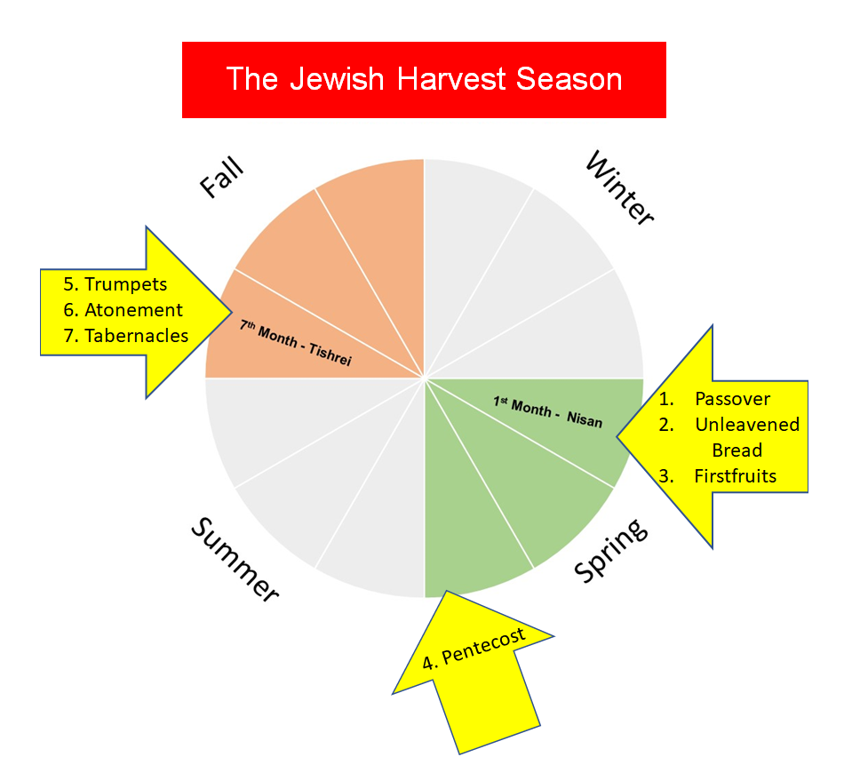

Judges

**18**Appoint judges and officials for each of your tribes in every town the Lord your God is giving you, and they shall judge the people fairly. **19**Do not pervert justice or show partiality. Do not accept a bribe, for a bribe blinds the eyes of the wise and twists the words of the innocent. **20**Follow justice and justice alone, so that you may live and possess the land the Lord your God is giving you.

Worshiping Other Gods

**21**Do not set up any wooden Asherah pole beside the altar you build to the Lord your God, **22**and do not erect a sacred stone, for these the Lord your God hates.

**17**Do not sacrifice to the Lord your God an ox or a sheep that has any defect or flaw in it, for that would be detestable to him.

**2**If a man or woman living among you in one of the towns the Lord gives you is found doing evil in the eyes of the Lord your God in violation of his covenant,**3**and contrary to my command has worshiped other gods, bowing down to them or to the sun or the moon or the stars in the sky, **4**and this has been brought to your attention, then you must investigate it thoroughly. If it is true and it has been proved that this detestable thing has been done in Israel, **5**take the man or woman who has done this evil deed to your city gate and stone that person to death. **6**On the testimony of two or three witnesses a person is to be put to death, but no one is to be put to death on the testimony of only one witness. **7**The hands of the witnesses must be the first in putting that person to death, and then the hands of all the people. You must purge the evil from among you.

Courts of Law

**8**If cases come before your courts that are too difficult for you to judge - whether bloodshed, lawsuits or assaults - take them to the place the Lord your God will choose. **9**Go to the Levitical priests and to the judge who is in office at that time. Inquire of them and they will give you the verdict. **10**You must act according to the decisions they give you at the place the Lord will choose. Be careful to do everything they instruct you to do. **11**Act according to whatever they teach you and the decisions they give you. Do not turn aside from what they tell you, to the right or to the left. **12**Anyone who shows contempt for the judge or for the priest who stands ministering there to the Lord your God is to be put to death. You must purge the evil from Israel. **13**All the people will hear and be afraid, and will not be contemptuous again.

The King

**14**When you enter the land the Lord your God is giving you and have taken possession of it and settled in it, and you say, “Let us set a king over us like all the nations around us,” **15**be sure to appoint over you a king the Lord your God chooses. He must be from among your fellow Israelites. Do not place a foreigner over you, one who is not an Israelite. **16**The king, moreover, must not acquire great numbers of horses for himself or make the people return to Egypt to get more of them, for the Lord has told you, “You are not to go back that way again.”**17**He must not take many wives, or his heart will be led astray. He must not accumulate large amounts of silver and gold.

**18**When he takes the throne of his kingdom, he is to write for himself on a scroll a copy of this law, taken from that of the Levitical priests. **19**It is to be with him, and he is to read it all the days of his life so that he may learn to revere the Lord his God and follow carefully all the words of this law and these decrees **20**and not consider himself better than his fellow Israelites and turn from the law to the right or to the left. Then he and his descendants will reign a long time over his kingdom in Israel.

Offerings for Priests and Levites

**18**The Levitical priests - indeed, the whole tribe of Levi - are to have no allotment or inheritance with Israel. They shall live on the food offerings presented to the Lord, for that is their inheritance. **2**They shall have no inheritance among their fellow Israelites; the Lord is their inheritance, as he promised them.

**3**This is the share due the priests from the people who sacrifice a bull or a sheep: the shoulder, the internal organs and the meat from the head. **4**You are to give them the firstfruits of your grain, new wine and olive oil, and the first wool from the shearing of your sheep, **5**for the Lord your God has chosen them and their descendants out of all your tribes to stand and minister in the Lord’s name always.

**6**If a Levite moves from one of your towns anywhere in Israel where he is living, and comes in all earnestness to the place the Lord will choose, **7**he may minister in the name of the Lord his God like all his fellow Levites who serve there in the presence of the Lord. **8**He is to share equally in their benefits, even though he has received money from the sale of family possessions.

Occult Practices

**9**When you enter the land the Lord your God is giving you, do not learn to imitate the detestable ways of the nations there. **10**Let no one be found among you who sacrifices their son or daughter in the fire, who practices divination or sorcery, interprets omens, engages in witchcraft, **11**or casts spells, or who is a medium or spiritist or who consults the dead. **12**Anyone who does these things is detestable to the Lord; because of these same detestable practices the Lord your God will drive out those nations before you. 13You must be blameless before the Lord your God.

The Prophet

**14**The nations you will dispossess listen to those who practice sorcery or divination. But as for you, the Lord your God has not permitted you to do so.**15**The Lord your God will raise up for you a prophet like me from among you, from your fellow Israelites. You must listen to him. **16**For this is what you asked of the Lord your God at Horeb on the day of the assembly when you said, “Let us not hear the voice of the Lord our God nor see this great fire anymore, or we will die.”

**17**The Lord said to me: “What they say is good. **18**I will raise up for them a prophet like you from among their fellow Israelites, and I will put my words in his mouth. He will tell them everything I command him. **19**I myself will call to account anyone who does not listen to my words that the prophet speaks in my name.**20**But a prophet who presumes to speak in my name anything I have not commanded, or a prophet who speaks in the name of other gods, is to be put to death.”

**21**You may say to yourselves, “How can we know when a message has not been spoken by the Lord?” **22**If what a prophet proclaims in the name of the Lord does not take place or come true, that is a message the Lord has not spoken. That prophet has spoken presumptuously, so do not be alarmed.